Desktop Virtualization: What’s in it for me and my patients?
Summary Report of Desktop Virtualization Remote
Mini-forum

July 2011

Intentionally left blank

Table of Contents
Overview 1
Introduction and Background 1
Desktop Virtualization Definition 2
Highlights from Literature Review on Desktop Virtualization 3
Current Day Workflow Challenges 4
PACT Model and Desktop Virtualization Technology 4
Desktop Virtualization Benefits and Drawbacks 5
Potential Barriers to Implementation 7
Desktop Virtualization User Reviews 8
Question & Answer 8

LIST OF FIGURES
Figure 1: Introductory poll 1
Figure 2: Do you currently use desktop virtualization? 3
Figure 3: Have you or others made an effort to implement desktop virtualization at your facility? 7

Overview
On July 13, 2011, the VHA Emerging Health Technologies Office hosted a remote mini-forum to explore desktop virtualization technology. Entitled “Desktop Virtualization: What’s In It for Me and My Patients?”, the session provided an overview of the definition of desktop virtualization, summarized highlights from a literature review on desktop virtualization technology, and explored current workflow challenges associated with use of this technology. The presentation ended with a discussion of scenarios where this technology could be of use in relation to the Patient Aligned Care Team (PACT) model; the benefits and drawbacks of desktop virtualization; and the potential barriers to implementation. This document provides a summary of information presented during this session.

Introduction and Background
Led by Steve Kator, MD, FACP, VA Eastern Colorado HealthCare System and Blake Lesselroth, MD, MBI, Portland VAMC, the desktop virtualization remote mini-forum opened with an introductory poll where session attendees could provide information about themselves. Nine attendees completed the introductory poll, the results of which are illustrated in Figure 1.
Figure 1: Introductory poll
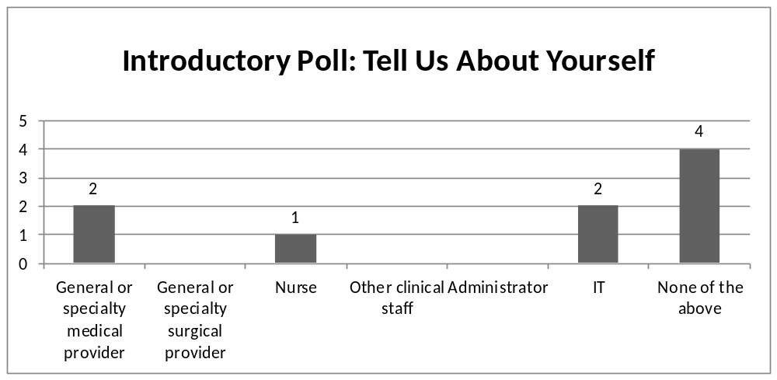
Both Dr. Kator and Dr. Lesselroth began with a brief introduction. Dr. Kator is a general internist working in Colorado Springs. As part of his clinical work, he has used desktop virtualization quite a bit, as it is his only means to access the VA network from his location in Fort Carson. Dr. Lesselroth is a general internist, hospitalist and informaticist working in Portland, Oregon. Dr. Kator also noted that Kevin Overholt, Desktop Technologies Director for Enterprise Systems Engineering (ESE), was listening in on the session and is knowledgeable on desktop virtualization from a technical standpoint.
Dr. Kator explained that the desktop virtualization remote mini-forum is part of the Point of Care (POC) Information Technology (IT) Assessments initiative, within the VHA Emerging Health Technologies (EHT) Office, which is part of the VHA Office of Informatics and Analytics. The POC IT Assessments initiative investigates information technologies using a variety of approaches. The three most common approaches used include: user reviews; formal assessments where technology is investigated in a laboratory-like setting; and literature reviews. A literature review on desktop virtualization technology is currently available on the EHT POC Library and is discussed in further detail later in the session.
Desktop virtualization was rated in the top three technologies of interest for FY2011 by VHA clinicians queried by the POC IT Assessments initiative. This high degree of interest prompted the development of the desktop virtualization remote mini-forum. Before going into further detail, Dr. Kator turned the session over to Dr. Lesselroth to provide additional information on the basics of desktop virtualization technology.

Desktop Virtualization Definition
Beginning the discussion on the definition of desktop virtualization, Dr. Lesselroth explained that, in a traditional work environment, a clinician’s workstation includes a computer with the capability to perform a variety of functions independent of a connection to a network or server. In other words, most of the applications and resources in use are hosted locally on the computer itself. Dr. Lesselroth noted that this does not imply complete self-containment for information accessed by the clinician. Some frequently used information (e.g., CPRS data) is accessed via a server and most of the user experience and available resources are housed on the workstation itself.
Dr. Lesselroth then posited the question to participants: what about desktop virtualization? How is it different from the traditional environment? Dr. Lesselroth explained that desktop virtualization differs from the traditional workstation model in that most of the applications and resources used are not hosted locally on the computer, but on a secure and accessible remote server. In other words, desktop virtualization refers to a configuration where each user’s desktop runs as a virtual machine on a server in the network, meaning the operating system as well as all applications and data are stored centrally. Under desktop virtualization, the computer essentially serves as a “glorified web browser”: each item seen or application used is stored elsewhere but linked to the workstation. From the user’s perspective, this means that you can access your workstation’s desktop from multiple locations and/or devices, ideally with a dedicated sign on/sign off. It also implies more opportunities for remote connectivity and increased provider mobility.
Upon completing his explanation of desktop virtualization, Dr. Lesselroth polled the audience on their use of desktop virtualization. As illustrated in Figure 2, of the 11 participants responding to this question, 8 reported that they did not use desktop virtualization.
Figure 2: Do you currently use desktop virtualization?
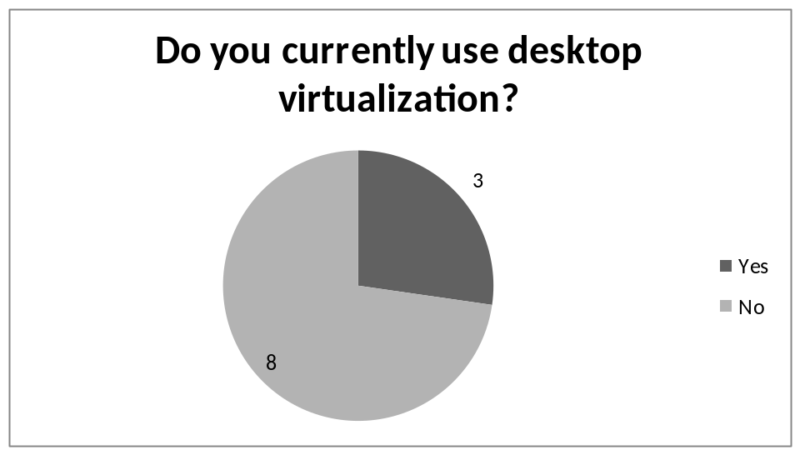

Highlights from Literature Review on Desktop Virtualization
Dr. Kator summarized highlights from the literature review on desktop virtualization technology available through the POC Library. In particular, Dr. Kator pointed out the following examples included within the literature review:
- At St. Vincent Catholic Medical Centers, “zero clients” have been implemented with VMWare servers. Zero clients are workstations that have no function other than a display, a keyboard, and a mouse. They have no significant processing capabilities other than ability to run a server client.
- At Overlake Hospital in Bellevue, Washington, Wyse thin clients have been installed with VMWare servers. These thin clients have some functionality; similar to what may be experienced using a VPN connection. However, they do not have every capability normally found on an office workstation.
- At Raritan Bay Medical Center in New Jersey, Wyse thin clients were implemented with Citrix servers. (The VHA also uses Citrix for remote networking purposes.)
- At Columbia Memorial Hospital in Hudson, New York, Wyse thin clients were installed with VMWare servers.
Dr. Kator then turned the discussion over to Dr. Lesselroth to discuss some of the workflow challenges that clinicians in the VHA currently experience and how desktop virtualization can address these issues.

Current Day Workflow Challenges
In order to provide context to the roles and benefits of desktop virtualization, Dr. Lesselroth discussed some of the current workflow challenges clinicians encounter.
The first workflow issue identified by Dr. Lesselroth was the challenge of supporting clinicians’ current workstations. He described the difficulty experienced in ensuring that all clinicians have access to the array of applications necessary to deliver seamless care to patients. Dr. Lesselroth also noted that, as more applications are hosted on a typical workstation, the problems associated with delivering resources and technical support increases. The workstation can even become overloaded with software applications.
Dr. Lesselroth also pointed out that, in the current configuration, clinician profiles are tethered to workstations. In other words, workstation resources, configurations and computer settings are frequently set locally to provider specifications. While useful for achieving high levels of provider productivity and efficiency, such settings are frequently not transferable between workstations. Considering the high mobility of clinicians in the work setting, it is clear that this set-up is not optimal.
Another workflow challenge described by Dr. Lesselroth is the lack of access to information outside of the facility area network. Speaking from personal experience as a hospitalist, Dr. Lesselroth explained that many of his responsibilities fall outside of typical work hours, such as reviewing charts in the middle of the night, when access to a workstation is not realistic. With desktop virtualization, however, Dr. Lesselroth is able to launch a session whenever needed and have access to the same types of resources that would be available to him if he were on-site.

PACT Model and Desktop Virtualization Technology
Dr. Kator then transitioned to discussing the use of desktop virtualization in conjunction with the VA’s Patient Aligned Care Team (PACT) model. This model stems from the idea of the Patient-Centered Medical Home (PCMH), a national initiative to improve the coordination of care for patients. In this model, a team of clinicians provides and coordinates care for a given patient. Each team consists of multiple staff involved in care delivery, such as physicians, registered nurses, nurse practitioners, and pharmacists, as well as other care providers. During a care encounter, the patient will visit with several members of the team. During this process, however, the patient remains in one room and does not move from clinician to clinician – a physical manifestation of the idea that patient-centered care is being delivered, instead of the patient moving around to see doctors, nurses, pharmacists, and other care providers. .
In order to successfully implement the PACT model, current workflows will have to change, as clinicians will no longer be able to limit their patient visits to their workstation location. Two simple solutions have been proposed:
- In the first solution, a mobile device, such as a touch pad tablet or a tablet PC, could be used as part of the PACT model. Clinical staff could carry the device from location to location to see a patient’s profile and gain access to the resources that are needed to deliver care.
- In the second solution, desktop virtualization could be used. A clinician could enter a room for the PACT visit and utilize the workstation along with a PIV card and PIN or fingerprint reader to quickly log onto their CPRS session without an interruption in workflow.

Desktop Virtualization Benefits and Drawbacks
Dr. Kator then explained that, aside from its potential utility as part of the PACT model, desktop virtualization has other benefits. For example, this technology offers the capability for centralized management of applications. In practical terms, this would allow for streamlining of application maintenance, significantly lessening the need to shut down CPRS at a particular hour in order to update the system. It would also eliminate the need to have support staff visit clinicians’ workstation to download items directly to individual machines.
Dr. Kator also explained the potential impact of desktop virtualization technology on costs. Currently, clinician workstations are replaced every few years because the software used by clinicians can require increased processing power and expensive upgrades. With desktop virtualization technology, software and hardware upgrades would be limited to the server and individual workstations may not have to be replaced as often.
Dr. Kator also identified some downsides associated with the use of desktop virtualization. First, with the transition to hosting more applications on a central server with this technology, additional bandwidth is required on the network. Thus, many VA facilities may be required to upgrade their networks to accommodate additional bandwidth. On a similar note, many of the servers currently used in VA facilities are very simple. As a result, when more applications are hosted centrally with desktop virtualization, servers will become relatively more expensive and difficult to maintain.
At this point in the session, Dr. Kator requested that the audience respond to a few questions on issues related to desktop virtualization.
- The first question inquired as to the whether desktop virtualization technology allows clinicians to perform their work more efficiently. Only one response was received from the audience and that participant strongly agreed with this statement.
- The second question inquired as to whether desktop virtualization technology requires additional time or effort to complete work. Again, one participant responded and that individual agreed with this statement.
Based on the small number of responses to these questions, Dr. Kator and Dr. Lesselroth recognized that most of the audience members are not currently using desktop virtualization technology. They commented that, although they work in ambulatory and inpatient settings, respectively, they both felt that they could not do their work effectively without the technology. Dr. Lesselroth recognized that, although the technology is not perfect, it has facilitated substantial progress in closing gaps in the quality of health care delivery. Dr. Lesselroth and Dr. Kator then asked the audience to reply to another poll regarding attempts to implement desktop virtualization.
Figure 3: Have you or others made an effort to implement desktop virtualization at your facility?
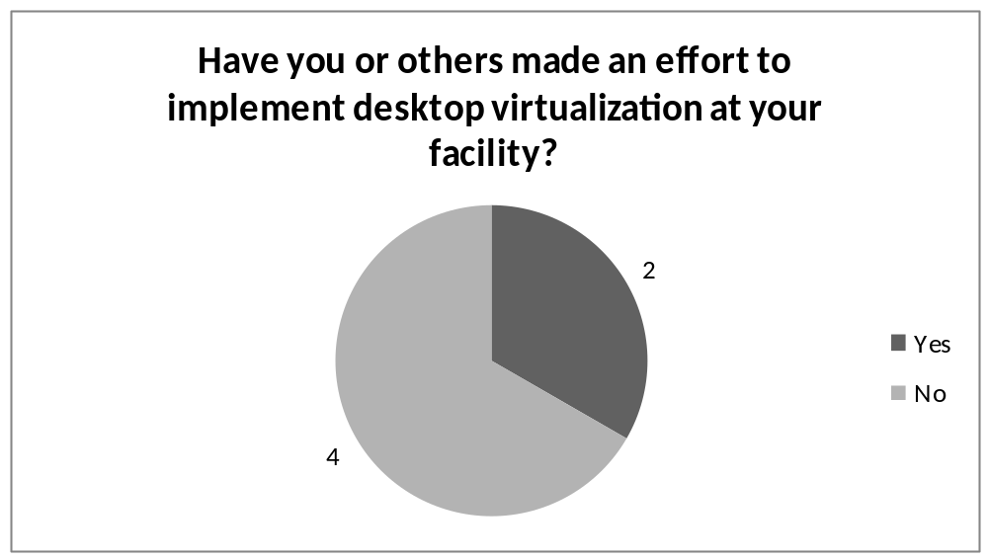
As illustrated in Figure 5, 4 participants responded that they or others at their facility have not made an effort to implement desktop virtualization, while 2 participants reported that they or others at their facility had made an effort to implement the technology.

Potential Barriers to Implementation
Recognizing that few participants had attempted to implement desktop virtualization, Dr. Kator proceeded with reviewing potential barriers to the adoption of the technology so that the participants could better understand what obstacles might lay ahead.
- Lack of local champion: Dr. Kator explained that having a clinician as a supporter of the adoption of the technology can facilitate smooth implementation.
- Lack of executive sponsorship: Similar to the importance of a local champion, it is also important for a senior organization member to be in support of the implementation of desktop virtualization technology for implementation purposes.
- Lack of IT staff support: Dr. Kator explained that he has experienced problems with this barrier at his facility. This issue is especially important when communication is required between VA facilities (e.g., VAMC and CBOC). Oftentimes technical support comes from a variety of sources and it is important to integrate these sources prior to adoption.
- Lack of consensus between information security, IT, and clinical departments: A lack of consensus about how to implement the technology was identified specifically as a potential roadblock. Dr. Kator suggested cross-department meetings as a potential solution to this issue.
- Lack of budget to purchase new hardware and software: Dr. Kator identified this barrier as an issue that may be experienced by some facilities.
- Inadequate bandwidth or connectivity: Dr. Kator explained that an effective Wi-Fi network is crucial, especially if mobile devices are being used.
- Conflict with other institutional priorities or policies: Dr. Kator recommended avoiding this barrier by ensuring effective coordination with senior leadership at the institution where the technology is being implemented.

Desktop Virtualization User Reviews
Dr. Kator showed the remote mini-forum participants the web site for the POC Library, where a user review for desktop virtualization technology is posted. Dr. Kator encouraged participants to click on the “add your knowledge” link to complete a review of the technology, or look at “show all reviews” to see what others have reported. Dr. Kator explained that the user review is a way to gather clinicians’ input to share with VA leadership and voice clinicians’ perspective on this technology. Dr. Lesselroth also emphasized the importance of the user reviews, explaining that, even though clinicians from across the country may not have identical experiences, it is nevertheless important to get a reasonable approximation of the landscape and to share with others what your experience has been.

Question & Answer
After concluding the presentation portion of the webinar, Dr. Kator and Dr. Lesselroth opened a question and answer session for participants. To kick-off the session, Dr. Lesselroth echoed a question he frequently receives from clinicians regarding the computer-specific accessibility of desktop virtualization from home computers: if a clinic’s operating system for desktop virtualization is based off of a PC, can a Mac or other user at home expect to have access from said home computer? Dr. Lesselroth explained that yes, desktop virtualization affords a significant amount of flexibility between computer operating systems. While an initial investment in workstation technology to support multi-computer operating systems is required, the cost is nominal and should not persist over time.
Continuing the question and answer discussion, Dr. Lesselroth presented a technical inquiry he often receives from clinicians: how seamless are the resources of the desktop virtualization interface as opposed to those on the interface of a workstation? Answering the question based on his personal experience, Dr. Lesselroth explained that the usability of resources on the desktop virtualization interface is usually quite good, adding that he finds that the experience charting and accessing email to be similar to what he experiences at his workstation. He cautioned, however, that accessibility can be limited when accessing content requiring multimedia capabilities, such as radiology images or videos, due to the use of thin clients and limitations on connection bandwidth. Dr. Lesselroth warned that this accessibility issue could be a potential downside for clinicians requiring access to this type of content as part of their clinical duties.
Following the theme of the previous question, Dr. Kator suggested another potential downside to desktop virtualization technology: response time. Speaking to the VA audience, he explained that those who have used remote access are aware that the response time for accessing information remotely is not as quick as it is from an on-site VA workstation. He continued noting that this issue requires a significant amount of attention from IT staff as there is no insurmountable technical reason for poor responsiveness if the server is adequately powered. While this is a potential problem with desktop virtualization, it also highlights the importance of having buy-in from the right people within the organization to provide the necessary resources to ensure adequate system responsiveness.
Dr. Lesselroth added to Dr. Kator’s point, cautioning that the experience and quality of services, as well as the availability of resources, is dependent on the local organization. Resource availability will be a key factor in determining the deployment and implementation of technology. Speaking about Dr. Lesselroth’s and his own experience, Dr. Kator confirmed that, while both clinicians have utilized and enjoyed the capabilities of desktop virtualization, they would caution that functionality is largely facility-specific and dependent on technical capabilities of the institution implementing the technology.
With no further questions in the queue Dr. Kator and Dr. Lesselroth ended the session by thanking the audience for their participation.

